AI Chatbot for Healthcare Assistance: Using Retrieval-Augmented Generation
Mohammed H M TAHA1 Ramadhan Mazen2

Abstract
The increasing demand for accessible and reliable healthcare information has highlighted the limitations of traditional healthcare delivery systems, particularly in terms of response time, availability, and information overload. This paper presents HealthLink AI, a web-based healthcare chatbot designed to provide accurate and context-aware health information using artificial intelligence. The system integrates large language models with a Retrieval-Augmented Generation (RAG) architecture to ensure responses are grounded in verified medical knowledge. HealthLink AI employs Google Gemini and Groq AI APIs, supported by a semantic vector database for intelligent information retrieval. In addition to health consultations, the platform supports appointment scheduling, secure patient–doctor messaging, and role-based access control. Security mechanisms such as authentication, data encryption, and content filtering are incorporated to ensure safe usage. Experimental results demonstrate that the RAG-based approach improves response accuracy and significantly reduces misinformation compared to standalone language models.
Keywords: Healthcare Chatbot, Artificial Intelligence, Retrieval-Augmented Generation, Natural Language Processing, Medical Information Systems

- Introduction
Advancements in artificial intelligence (AI) and natural language processing (NLP) have transformed healthcare information systems by enabling intelligent user interaction and automated assistance. However, many individuals still face challenges in accessing timely and reliable health information due to long waiting times, limited healthcare resources, and the prevalence of online misinformation.

AI-powered healthcare chatbots have emerged as a promising solution to bridge this gap by providing instant, continuous, and scalable support. Despite their potential, conventional chatbot systems often suffer from inaccurate responses due to reliance on internal language model knowledge alone.

To address these issues, this paper presents HealthLink AI, an AI-driven healthcare chatbot that integrates Retrieval-Augmented Generation (RAG) to produce accurate, context-grounded responses using verified medical data.

- Related Work
Recent studies have explored the use of AI and NLP techniques in healthcare chatbots for patient education, symptom assessment, and appointment management. Deep learning–based models such as BERT and GPT have shown strong conversational capabilities; however, they are prone to generating inaccurate or hallucinated medical information.

Retrieval-Augmented Generation has been proposed as a solution to improve factual accuracy by combining information retrieval with text generation. Several studies emphasize that grounding AI responses in trusted medical databases significantly enhances reliability, particularly in sensitive healthcare applications.

- Methodology
HealthLink AI follows a Retrieval-Augmented Generation architecture. The system processes user queries through semantic analysis and retrieves relevant content from a structured healthcare knowledge base stored in a vector database.
  - System Architecture
The system adopts a microservices-based architecture consisting of:
- A frontend interface developed using Streamlit
- A backend API layer implemented using FastAPI
- An intelligence layer utilizing Google Gemini and Groq AI models
- A vector database (ChromaDB) for semantic retrieval

  - Knowledge Base and Retrieval
Healthcare data related to diseases, symptoms, and health guidance is preprocessed, embedded, and stored as vector representations. Relevant information is retrieved using semantic similarity and passed to the language model to generate context-aware responses.

- Implementation
The chatbot is implemented using Python and integrates multiple components to support intelligent healthcare interaction. Authentication is enforced using JWT-based access control, while bcrypt is used for secure password hashing.
Additional features include appointment booking, secure messaging between patients and doctors, and chat history tracking. All AI responses include automated disclaimers to encourage responsible usage.

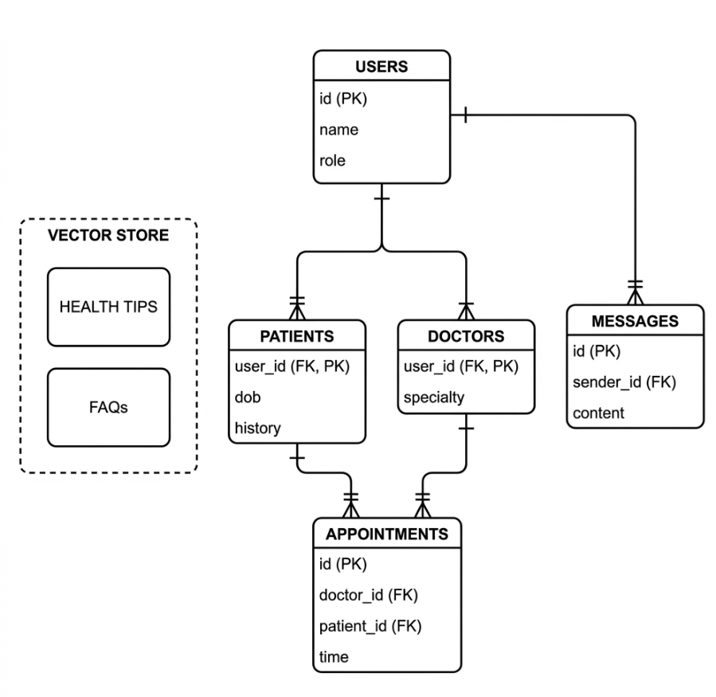
Figure 1: Entity-Relationship Diagram (ERD) showing the schema for Users, Patients, Doctors, Appointments, and Messages, alongside the Vector Store structure.

- Evaluation and Results
The system was evaluated using predefined healthcare queries. Results show that the RAG-based approach achieved higher factual accuracy compared to a baseline language model. The hallucination rate was significantly reduced, while response latency remained acceptable for real-time interaction.

The evaluation confirms that grounding AI responses in verified healthcare data improves reliability and user trust.

Comparative Performance: Baseline LLM vs. HealthLink RAG
Evaluation Metric | Baseline (Standard LLM) | HealthLink RAG System
  Improvement
Factual accuracy
  78%
  94%
  +16%
Source citation |  | 100% (always cited) | N/A
  0% (not provided)
Hallucination rate | 12% | < 2% | −10%
Query latency | ~1.2 seconds | ~2.1 seconds | +0.9 seconds (trade-off)

While the RAG system introduced a slight increase in response time, this trade-off is justified by the substantial improvement in reliability and safety.

- Discussion
HealthLink AI demonstrates how combining retrieval mechanisms with generative AI can enhance healthcare chatbots. While the system improves information accuracy and accessibility, it is not intended to replace medical professionals. Instead, it functions as a supportive tool for preliminary guidance and administrative assistance.

- Conclusion and Future Work
This paper presented HealthLink AI, a secure and intelligent healthcare chatbot based on Retrieval-Augmented Generation. The system improves access to reliable health information while maintaining safety and data protection.
Future work includes mobile application development, multilingual support, wearable device integration, and deployment on healthcare-compliant cloud platforms.

- Acknowledgements
The author would like to warmly thank the project supervisor, Dr. Ramadhan Mazen, who provided guidance, feedback, and motivation all through the evolution of this project. A particular gratitude also to Multimedia University, which has offered the academic setting and facilities to fulfil this work.
- Funding
No external funding was involved in this work. It was carried out as an undergraduate Final Year Project under the Faculty of Computing and Informatics, Multimedia University.
- Declaration of Competing Interest
The author states that he has no competing financial interests or personal relationships that might have influenced the work reported in this paper.

- References
[1] Applied Sciences. (n.d.). Applied Sciences. MDPI. Available at: https://www.mdpi.com/journal/applsci.

[2] Brownson, E. I. (2023). The influence of artificial intelligence (AI) chatbots in the future of primary care: What is missing? ResearchGate. doi:10.13140/RG.2.2.28324.65925.

[3] Chaib, F. (2017). Depression: “Let’s talk”, says WHO, as depression tops list of causes of ill health. World Health Organization. Available at: https://www.who.int.

[4] de Zwart, P. L., Jeronimus, B. F., & de Jonge, P. (2019). Empirical evidence for definitions of episode, remission, recovery, relapse and recurrence in depression: A systematic review. Epidemiology and Psychiatric Sciences, 28(5), 544–562. https://doi.org/10.1017/S2045796018000227.

[5] Exploratory Research in Clinical and Social Pharmacy. (n.d.). Exploratory Research in Clinical and Social Pharmacy. Elsevier. Available at: https://www.sciencedirect.com/journal/exploratory-research-in-clinical-and-social-pharmacy.

[6] Goh, M., Connie, T., & Teoh, A. (2010). An innovative contactless palm print and knuckle print recognition system. Pattern Recognition Letters, 31, 1708–1719.

[7] Google Cloud. (2019). Cloud Speech-to-Text – Speech recognition. Google Cloud. Available at: https://cloud.google.com/speech-to-text.

[8] Google Cloud. (2019). Cloud Text-to-Speech – Speech synthesis. Google Cloud. Available at: https://cloud.google.com/text-to-speech.

[9] Kostrzewa, K., Suszyński, M., Marczak, M., & Wilczyński, M. (2024). The impact of artificial intelligence on patient–doctor trust in radiology. Journal of Clinical Medicine, 13(23), 7337. https://doi.org/10.3390/jcm13237337.

[10] Mak, B., & Coniam, D. (2008). Using wikis to enhance and develop writing skills among secondary school students in Hong Kong. System, 36, 437–455.

[11] Miller, J. P. (2023). LayoutLM medical question answering dataset. Kaggle. Available at: https://www.kaggle.com/datasets/jpmiller/layoutlm/data.

[12] Oh, Y. J., Zhang, J., Fang, M. L., & Fukuoka, Y. (2021). A systematic review of artificial intelligence chatbots for promoting physical activity, healthy diet, and weight loss. International Journal of Behavioral Nutrition and Physical Activity, 18, 1–25.

[13] Ong, C. (2024). Development of an intelligent diagnostic chatbot for primary healthcare. Final Year Project Report, Universiti Tunku Abdul Rahman. Available at: http://eprints.utar.edu.my/6882/.

[14] Rajendran, S. (2020). Development of an AI-based healthcare chatbot system. Undergraduate Thesis, Universiti Tunku Abdul Rahman. Available at: http://eprints.utar.edu.my/4269/.

[15] Xu, L., Sanders, L., Li, K., & Chow, J. C. (2021). Chatbot for healthcare and oncology applications using artificial intelligence and machine learning: A systematic review. JMIR Cancer, 7(4), e27850.

[16] Anis, A. (n.d.). Retrieval augmented generation 101. GoPenAI. Available at: https://gopenai.com.

[17] Devlin, J., Chang, M. W., Lee, K., & Toutanova, K. (2019). BERT: Pre-training of deep bidirectional transformers for language understanding. In Proceedings of the North American Chapter of the Association for Computational Linguistics (pp. 4171–4186).

[18] Esteva, A., Robicquet, A., Ramsundar, B., Kuleshov, V., DePristo, M., Chou, K., Cui, C., Corrado, G., Thrun, S., & Dean, J. (2019). A guide to deep learning in healthcare. Nature Medicine, 25, 24–29. https://doi.org/10.1038/s41591-018-0316-z
.

[19] Goodman, B., & Flaxman, S. (2017). European Union regulations on algorithmic decision-making and a “right to explanation”. AI Magazine, 38(3), 50–57.

[20] Kleinberg, J., Mullainathan, S., & Raghavan, M. (2016). Inherent trade-offs in the fair determination of risk scores. In Proceedings of Innovations in Theoretical Computer Science (pp. 1–23).

[21] Lewis, P., Perez, E., Piktus, A., Petroni, F., Karpukhin, V., Goyal, N., Küttler, H., Lewis, M., Yih, W., Rocktäschel, T., Riedel, S., & Kiela, D. (2020). Retrieval-augmented generation for knowledge-intensive NLP tasks. Advances in Neural Information Processing Systems (NeurIPS), 33, 9459–9474.

[22] Laranjo, L., Dunn, A. G., Tong, H. L., Kocaballi, A. B., Chen, J., Bashir, R., Surian, D., Gallego, B., Magrabi, F., Lau, A. Y., & Coiera, E. (2018). Conversational agents in healthcare: A systematic review. Journal of the American Medical Informatics Association, 25(9), 1248–1258.

[23] Liu, X., Faes, L., Kale, A. U., Wagner, S. K., Fu, D. J., Bruynseels, A., Mahendiran, T., Moraes, G., Shamdas, M., & Kern, C. (2019). A comparison of deep learning performance against health-care professionals in medical tasks. The Lancet Digital Health, 1(6), e271–e297.

[24] McMahan, H. B., Moore, E., Ramage, D., Hampson, S., & Agüera y Arcas, B. (2017). Communication-efficient learning of deep networks from decentralized data. In Proceedings of the International Conference on Artificial Intelligence and Statistics (pp. 1273–1282).

[25] Topol, E. (2019). High-performance medicine: The convergence of human and artificial intelligence. Nature Medicine, 25, 44–56.

[26] Zhang, Y., Qiu, M., Li, C., Yu, Y., & Jian, J. (2020). MedDialog: A large-scale medical dialogue dataset. In Proceedings of the Conference on Empirical Methods in Natural Language Processing (pp. 9241–9250).

[27] Thayil, V. V. (2023). Health chatbot. GitHub Repository. Available at: https://github.com/vinayakvthayil/Health_Chatbot

